**Boston University**

**Electrical & Computer Engineering**

**EC463 Senior Design Project**

Final Prototype Test Plan

**The Future of Heat**

Submitted to:

Marissa Petersile

National Grid

National Grid P.O. Box 960 Northborough, MA 01532-0960

1-800-322-3223

Marissa.Petersile@nationalgrid.com

by

**Team 17**

**The Future of Heat**

Team Members

Muayad Al Riyami - [mriyami@bu.edu](mailto:mriyami@bu.edu)

Ben Gross - [bengee19@bu.edu](mailto:bengee19@bu.edu)

Seunghak Shin - [seunghak@bu.edu](mailto:seunghak@bu.edu)

Fatima Dantsoho - [dantsoho@bu.edu](mailto:dantsoho@bu.edu)

Andrew Chen - [achen17@bu.edu](mailto:achen17@bu.edu)

Submitted: 3/31/2021

**Required materials**

* Hardware
  + Function generator
  + DC power supply
  + Oscilloscope
  + Cables/wires
  + Town load units (PCB boards)
  + Breadboards
  + **Arduino Mega 2560 R3**
  + **ESP8266 Feather Huzzah**
* Software
* **HTML 1 script**
  + Front end page
* **JavaScript 2 scripts**
  + Create output graphs
  + Read from and Write to firebase database
* **Firebase Database**

**Set Up**

* **Web Application:** The web application is the main user interface. The user makes a selection of the adoption rate of electric homes and eclectic vehicles and the weather condition. The user input is used to calculate the amount of houses and vehicles on the diorama that will be heated electrically and the calculated values will be pushed to the firebase database. The arduino updates the load profiles of each house based on the user inputs and the updated values are read by the web application and load, cost and CO2 Emission of each house is plotted in the output section.
* **Circuit:** Connect the transformer to the circuit and plug it into a wall socket. Using the oscilloscope, probe the voltage at the node between the load resistor and the AC relay. Now, all that is left is to apply the DC voltage to turn a desired relay on. We will test if the house unit PCB we built works as intended by demonstrating that each load branch is controlled by the relays.
* **Arduino Mega + ESP8266 Component:** Turn on all the battery packs attached to the front of the diorama, by flipping the power switches to ON, refer to **Figure.2**. Connect the USB power cables for the Arduino Mega and the ESP8266 to an accompanying laptop. To set up the Wifi connection for the ESP8266 edits to the Wifi SSID and Wifi password sections of the ESP8266 [Github code](https://github.com/BostonUniversitySeniorDesign/21-17-Future-of-Heat-Arduino/tree/main/ESP8266BasicTest1) should be done, reupload this code to the ESP8266 through the Arduino IDE. The simplest method of connecting to Wifi will be setting up a mobile hotspot on the current Wifi network, remember to set the network band to 2.4 GHz. Upon ensuring the Arduino Mega and ESP8266 are properly powered and connected, this project portion is ready for testing.

**Pre-testing Set Up Procedure**

* **Web Application**

1. Initialize firebase database using terminal - $firebase init
2. Open the index.html file with the web browser (Google Chrome).

**Testing-Procedure**

* **Web Application**

1. Open the index.html file with the web browser (Google Chrome).
2. Press the “Click to Start” button to begin.
3. Select input for electric home and vehicle adoption rate and weather using the range slider
4. Click the Enter button to process and upload inputs to the firebase and receive the load profiles for each house.
5. The Load profile array and CO2 Emission, Cost and Load profile Line graphs should be displayed in the “Output” section.

* **Circuit**

1. The success of the test relies on whether the house unit PCBs are built correctly according to design and that the design is functional. The main goal of the house unit circuit is to control the load (allow current to flow through or not) using voltage controlled AC relays.
2. Apply 5 volts to a specific relay and probe the voltage of the load resistors using the oscilloscope.
3. If the relay is off (open circuit), then the oscilloscope reading should be the same as the function generator output (no voltage drop across load resistor). If the relay is on (closed circuit), then the oscilloscope reading should be approximately zero as it is now connected to ground.

* **Arduino Mega + ESP8266 Component:**

1. Upon finishing up the setup process correctly the diorama will work automatically.
2. As the user changes the parameters for the percentage of electric heating adoption, percentage of electric vehicle adoption, and temperature severity on the Web App, the LEDs mounted on and within the models houses should correspondingly change.

**Measurable Criteria**

* **Web Application**

1. Database resets all values to 0 when the “Click to start” button is clicked.
2. Databases should be automatically updated once the inputs are entered.
3. Load Profile output should be displayed as an array in the output section.
4. All graphs should be populated.

* **Arduino Mega + ESP8266 Component**

1. R/G LEDs mounted on the house roofs should correspond to Web App input of ⌊% Electric Heating adoption * Total Number of Heating Units⌋. This is since the total number of heating units is 17, rounding down should decimals appear.
2. R/B LEDs mounted within the houses should simulate houses heating up. This heating up rate is dependent on the inputted weather severity and fixed house size.
3. Note that currently there are 11 residential homes and 1 hotel. One home signifies a heating load and an electric vehicle load, while the hotel signifies six heating loads and six electric vehicles. When adoption exceeds 50% the hotel load is placed in. E.g. Electric heating for hotel (6 units) and two other houses (2 units) for a total of 8 units is ⌊50% * 17 units⌋, more specifics are written in **Figure.2**.

* **Circuit**
  1. Current passing through the electric heating branch.
  2. Current passing through the electric vehicle branch.
  3. A successful test should have currents passing through the loads when the relay control voltage is high and none through them when it is low.

**Score Sheet**

* **Web Application**

|  |  |  |  |  |  |  |
| --- | --- | --- | --- | --- | --- | --- |
| **User Input** | | | **Result** | | | **Correct? (Y/N)** |
| **electric homes adoption rate (%)** | **electric vehicles adoption rate (%)** | **Weather (F)** | **# of homes** | **# of EV** | **Weather Severity** |
| 50 | 10 | 10 | **6** | **1** | **5** | **Y** |
| 40 | 50 | 20 | **4** | **8** | **4** | **Y** |
| 70 | 30 | 30 | **8** | **5** | **3** | **Y** |
| 20 | 40 | 40 | **2** | **6** | **2** | **Y** |
| 80 | 70 | 50 | **9** | **11** | **1** | **Y** |
| **Result** All tests were passed and updated automatically to the web database | | | | | |  |

* **Arduino Mega + ESP8266 Component**

|  |  |  |  |  |  |
| --- | --- | --- | --- | --- | --- |
| **Red/Green Dual LED Metrics** | | **Red/Blue Gradient (Heating Visual)** | | | **Time Delay <2 LED change?**  **(Y/N)** |
| **# Electric Homes Input**  **(% * 12)** | **Correct Corresponding LEDs? (Y/N)** | **Visual differences in “heating times” depending on weather severity input and on module sizes?** | | |
| 6 |  |  |  |  |  |
| 4 |  |  |  |  |
| 8 |  |  |  |  |
| 2 |  |  |  |  |
| 9 |  |  |  |  |
| **Result** | | | | |  |

* **Circuit**

|  |  |  |
| --- | --- | --- |
|  | Current through Electric Heating | Current through Electric Vehicle |
| Relay control voltage - High |  |  |
| Relay control voltage - Low |  |  |

**Appendix**

**Figure.1: Housing Load Test Schematic**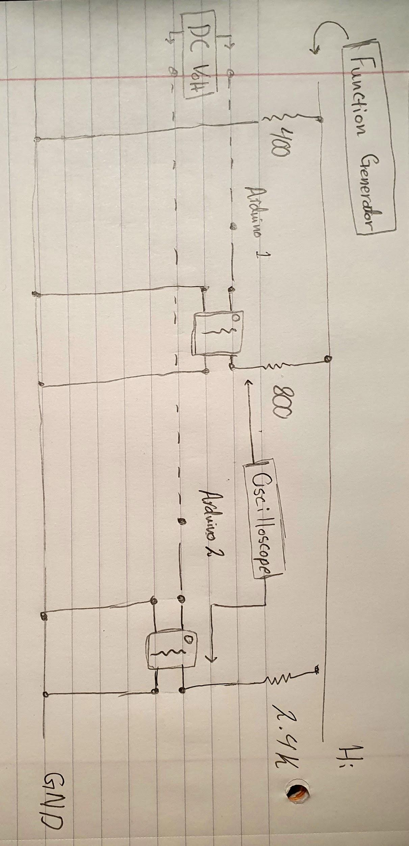

**Figure.2: Diorama Physical Schematic**